BỘ XÂY DỰNG
TRƯỜNG ĐẠI HỌC GIAO THÔNG VẬN TẢI TP.HCM
VIỆN ĐÀO TẠO CHẤT LƯỢNG CAO



BÁO CÁO PROJECT: STUDENT MANAGER SYSTEMS

Nhóm: 08
Giảng viên hướng dẫn: Trần Thị Mỹ Tiên
Môn học: Công nghệ phần mềm
Khoa/ngành: Công nghệ thông tin.

TP. Hồ Chí Minh, ngày 29 tháng 10 năm 2026.
- Functional requirement
1. Student Management System
The university needs to build a Student Management System with the following basic account management features, for two groups of users: administrators (Admin) and students:
- Login, logout and change password:
- Login: Administrators and students can log in to the system with their username (or email) and password. The system validates the input data and checks it against the database. If the information is valid, the system creates a session (Session/Token) and redirects the user to the interface that matches their role: administrators go to the Admin Dashboard, students go to the student interface. If wrong information is entered more than 5 times, the system temporarily locks the account for 15 minutes.
- Logout: Administrators and students can log out of the system at any time to end their working session. On logout, the system destroys the current login session (Session/Token), clears the browser cache and redirects the interface to the login page.
- Change password: Administrators and students can change their own password while logged in.
- Change password process:
▪ The system asks the user to enter the current password, new password and new password confirmation.
▪ The system validates the data: the current password must be correct, the new password must differ from the old one and meet the minimum length (6-8 characters).
▪ If validation succeeds, the system hashes the new password and updates the database, and displays a password changed successfully message.
- Viewing and searching for members:
- Administrators can view a list of students filtered by Faculty, Major, or Class. The list can be sorted (in ascending or descending order) based on criteria such as student ID, name, or cumulative grade point average (GPA).
- Administrators can search for students by entering a keyword. The system will return a list of students whose names or student IDs contain that keyword. The search results can also be sorted (in ascending or descending order) by student ID, name, or GPA.
- Viewing details and adding new members:
- Each student profile includes their full name, student ID, a photograph, a summary, detailed personal information, phone number, email address, and academic status (e.g., currently enrolled, on leave, graduated, or expelled). Each student is assigned to a specific major.
- When viewing or searching for students, administrators can access the full profile details for any individual student in the list.
- Procedure for adding new students:
- The system prompts the administrator to enter the student's information.
- Required student information includes: personal details, student ID, phone number, and email address.
- The system validates the data to ensure accuracy. Upon a successful new addition, the system will record the student's profile into the database.
- Updating information and deleting or changing status:
- Administrators may update any student information, with the exception of the student ID number (to ensure data integrity).
- Administrators may delete a student profile from the system only if it is a newly created record with no associated data (such as academic transcripts or tuition payment history).
- If a student already has academic data, administrators cannot delete the profile, instead, they must use the update function to change the student's status (e.g., changing the status from "Currently Enrolled" to "Withdrawn" or "Graduated").
- In the event that a student forgets their password, a password recovery function is available, the system will generate a new password and send it to the student's registered email address or phone number
- Search for students:
- Each student has a student ID (unique), a full name, a gender, and belongs to exactly one class.
- After logging in, the Admin selects the student search function and enters a keyword, which is a student ID or a full name. The Admin can filter the results by class or gender. The keyword may contain at most 100 characters and is case-insensitive. If the keyword is left blank, the system displays all students that match the selected filters.
- When the Admin selects search, the system validates the keyword. If the keyword exceeds the allowed length, the system displays an error and does not perform the search. The Admin can also reset the filters to return to the initial list.
- View search results:
- The system returns the list of students whose student ID or full name contains the keyword, including the student ID, full name, gender, and class. The list is paginated. If no student matches, the system displays a message stating that no students were found.
- The student list can be sorted (ascending or descending) by student ID, full name, or class. By default, the list is sorted in ascending order by student ID.
  - For each student in the list, the Admin can view the student's details or view the class information of the class the student belongs to.
- Authorization:
  - Only Admin can search for students across the whole system. Students can only view their own information and cannot search for or view other students' information.
- View and search classes:
  - Each class has a class code (unique), a class name, a class size, and a list of the students belonging to the class. Each student belongs to only one class. The class size is calculated automatically by the system based on the number of students in the class and is not entered manually.
  - After logging in, the Admin selects the class management function, and the system displays the list of classes, including the class code, class name, and class size. The list is paginated. If there are no classes yet, the system displays a message stating that no classes exist.
  - For each class in the list, the Admin can view the class details, edit, or delete the class.
  - The Admin can search for classes by entering a keyword. The system returns the list of classes whose class code or class name contains the keyword (case-insensitive). If no class matches, the system displays a message stating that no classes were found.
  - The class list can be sorted (ascending or descending) by class code, class name, or class size. By default, the list is sorted in ascending order by class code.
- Add a class:
  - The Admin selects the add class function and enters the class code and class name into the form. The class code is required, must be unique, may contain at most 20 characters, and must not contain spaces or special characters. The class name is required and may contain at most 100 characters.
  - When the Admin selects save, the system validates the data. If a required field is left blank, the format is invalid, or the class code already exists, the system displays an error and does not save. If the data is valid, the system saves the new class, displays a success message, and shows the class list again. The Admin can also cancel the operation to return to the list without saving.
- Update a class:
  - The Admin selects a class in the list and chooses edit. The system displays the current information of the class. The Admin may only update the class name, the class code cannot be changed once the class has been created.
  - When the Admin selects save, the system validates the data and updates the class information. If the data is invalid or the class has been deleted by someone else, the system displays an error and does not update.
- Delete a class:
  - The Admin selects a class in the list and chooses delete. The system requires the Admin to confirm the deletion before it is carried out.
  - A class can be deleted only when it has no students remaining. If the class still has students, the system does not allow the deletion and requires the Admin to transfer the students to another class first.
- View the students of a class:
  - When viewing the details of a class, the Admin can view the list of students in the class, including the student ID, full name, and gender. If the class has no students yet, the system displays a message stating that the class has no students.
- Authorization:
  - Only Admin can add, edit, and delete classes. Students can only view the information of their own class.
- Dashboard Overview:
  - Administrators can view a system overview, including the total number of students, the total number of classes, and the number of students enrolled in each class. This information is presented via statistical cards, allowing administrators to easily monitor student management data.
  - The system automatically updates these statistics whenever student or class data is added, modified, or deleted.
- Grade Management:
- Administrators can enter student grades for specific subjects and semesters. The system stores these grades for each student, facilitating the retrieval and management of academic performance.
- Administrators can update student grades whenever changes occur. The system retains the most recent grades to ensure that academic records remain accurate and up-to-date.
- Viewing Personal Information:
- Students can view their own personal information, including their student ID, full name, date of birth, gender, email address, phone number, and home address.
- Students can view details regarding the class in which they are enrolled, including the class code and class name.
- Viewing Class Information:
- Students can view details about their current class—such as the class code and name—to stay informed about their enrollment.
- Students can access their class schedule to keep track of their academic sessions.
- Viewing Grades:
- Students can view their cumulative grade point average (GPA) based on the academic results recorded in the system.
- Students can view their grades for individual subjects across different semesters to monitor their academic progress. + The system only allows students to view their own grades, ensuring that academic performance information is not accessed by other students without authorization.
- Non-Functional requirement
- Usability
  - The login and change-password screens use a minimal, well-balanced layout, with clear labels and placeholder hints.
  - The cursor is automatically focused on the Username field as soon as the user opens the page.
  - Pressing the Enter key submits the login or change-password form, so users do not need to move the mouse.
  - A Show/Hide password (eye) button is provided on the password fields, together with a password strength meter when the user creates a new password.
  - Error messages are displayed in Vietnamese, short and intuitive (inline errors), and the border of the input field turns red when the data is invalid.
- Reliability:
- The entire student management system (including the student portal and the interface for the academic affairs office/administrators) must remain operational 24/7.
- In the event of a critical server failure, the system must be restored to normal operation within a maximum of 4 hours.
- The system must perform a full automated data backup every 24 hours.
- The system must ensure data integrity when multiple users attempt to update the same record simultaneously, preventing "blind" overwrites or the entry of erroneous data.
- To ensure reliability, the system must not merely report errors after a failure occurs, instead, it must incorporate an automated mechanism to monitor resource "health" (RAM, CPU, disk space, etc.) and send early warning alerts to the administrator before thresholds that could trigger a failure are reached.
- Security Requirements
- Users must log in before accessing the system. Passwords must be at least 8 characters long and include uppercase letters, lowercase letters, and digits, they must be hashed with a salt before storage.
- The system implements role-based access control with two roles: Admin and Student. Admins have the authority to manage students, classes, grades, and statistics, while Students are restricted to viewing their own personal information, classes, and grades.
- Data transmitted between the browser and the server must be encrypted via HTTPS. Error messages must not disclose technical system details.
- The system logs significant events—such as logins, password changes, and data management operations—recording the user who performed the action and the timestamp. The database is backed up daily to allow for recovery in the event of a system failure.
- Performance Requirements
- Standard operations—such as logging in, viewing information, searching, and updating data—should complete within 3 seconds under normal load conditions.
- The system must support searching for students by student ID or full name, as well as filtering by class, while maintaining an acceptable response time as the volume of data grows.
- The system must be capable of handling multiple simultaneous users without encountering errors or experiencing a significant degradation in performance.
- The dashboard must display the total number of students, the number of classes, and the student count per class based on current data, with a reasonable loading time.
- Development requirement
- The system is developed using the C++ programming language to build a student management application.
- The system is designed based on the MVC (Model–View–Controller) pattern, which ensures a clear separation between the user interface, business logic, and data, thereby facilitating maintenance and future expansion.
- Data Flow Diagram
- Lv0:
Admin
Student
0.0
Student
Management System
Login credentials, logout request,
change-password request,
management data (students, classes, courses, grades)
Login credentials, logout request,
change-password request,
grade view request
Authentication result, notifications,
lists, reports
Login result, logout notification,
change-password result,
transcript
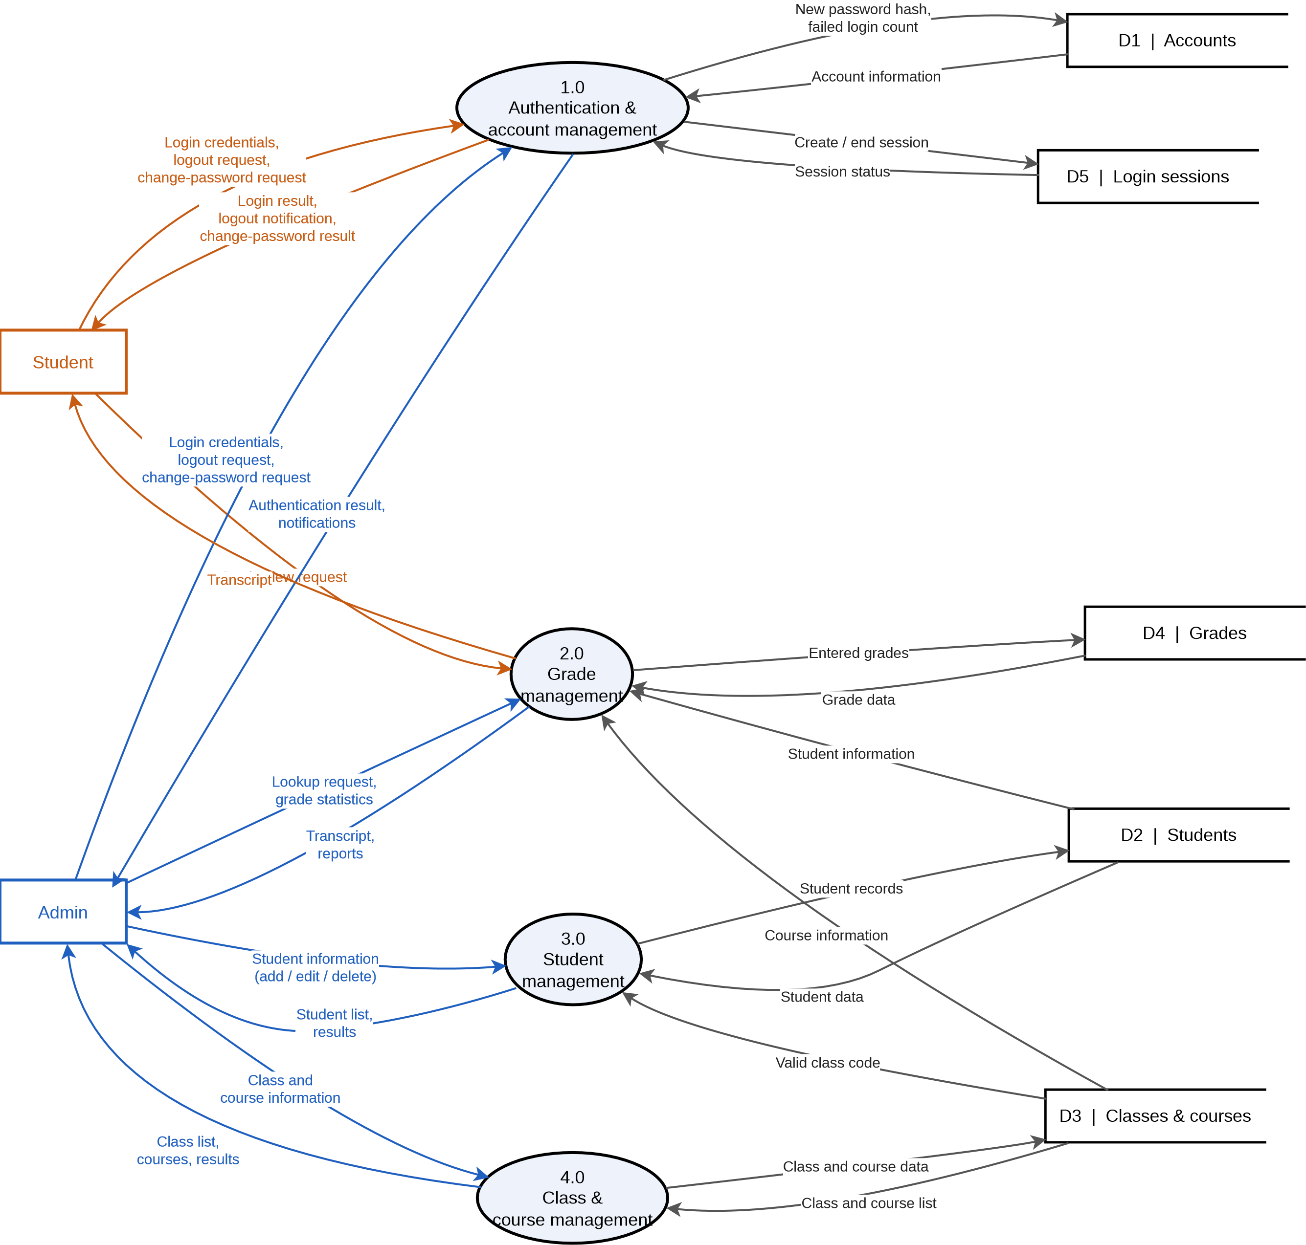
- Lv1:

- Use case Diagram
- Sơ đồ tổng quan
Student Management System
Add student
View student list and details
Update student information
Delete student
Search by student ID
Search by full name
Filter list by class
Add class
Delete class
Assign student to class
View class list
Edit class information
View total students
View total classes
View student count per class
Enter student grades
Update grades
Login, Logout
change password
Admin
User

View student ID, name, address...
View enrolled classes
View class code and name
View class schedule
View own GPA
View grades by subject and semester
Student

Actor List
No. | Actor | Description
1 | Admin | System administrator: manages students, classes, statistics and grades
2 | Student | Student: views own personal information, classes, schedule and academic results
3 | User | User: Login, logout, change password

Use Case List
No. | ID | Use Case | Description | Actor | Group
1 | UC01 | Add student | Add a new student | Admin | Student management
2 | UC02 | View student list and details | View the student list and each student’s details | Admin | Student management
3 | UC03 | Update student information | Update student information | Admin | Student management
4 | UC04 | Delete student | Delete a student | Admin | Student management
5 | UC05 | Search by student ID | Search students by ID | Admin | Student management
6 | UC06 | Search by full name | Search students by full name | Admin | Student management
7 | UC07 | Filter list by class | Filter the student list by class | Admin | Student management
8 | UC08 | Add class | Add a class | Admin | Class management
9 | UC09 | Delete class | Delete a class | Admin | Class management
10 | UC10 | Assign student to class | Assign a student to a class | Admin | Class management
11 | UC11 | View class list | View the list of classes | Admin | Class management
12 | UC12 | Edit class information | Edit class information | Admin | Class management
13 | UC13 | View total students | View the total number of students | Admin | Statistics
14 | UC14 | View total classes | View the total number of classes | Admin | Statistics
15 | UC15 | View student count per class | View the number of students in each class | Admin | Statistics
16 | UC16 | Enter student grades | Enter grades for a student | Admin | Grade management
17 | UC17 | Update grades | Update existing grades | Admin | Grade management
18 | UC18 | View student ID, name, address… | View personal information | Student | Personal information
19 | UC19 | View enrolled classes | View enrolled classes | Student | Classes
20 | UC20 | View class code and name | View class code and name | Student | Classes
21 | UC21 | View class schedule | View class schedule | Student | Classes
22 | UC22 | View own GPA | View own GPA | Student | Academic results
23 | UC23 | View grades by subject and semester | View grades by subject and semester | Student | Academic results

Detailed Use Case Specifications
Convention: the common precondition for Admin use cases is that the Admin is logged in for Student use cases, that the Student is logged in.

Student Management

UC01 – Add student

1.1. Summary
The Admin adds a new student to the system.

1.2. Flow of events

1.2.1. Main flow
- Admin selects Add student.
- System displays the input form (student ID, full name, date of birth, address, …).
- Admin enters the information and clicks Save.
- System validates the data, saves the student and shows a success message.

1.2.2. Alternative flows
1. Student ID already exists or a required field is missing: system shows an error and returns to step 3.

1.3. Special requirements
Only the Admin is authorized to perform this function.

1.4. System state before the use case
Admin is logged in.

1.5. System state after the use case
The new student is saved in the database.

1.6. Extension points
None.

UC02 – View student list and details

1.1. Summary
The Admin views the student list and the details of a student.

1.2. Flow of events

1.2.1. Main flow
- Admin opens the Student list.
- System displays the list of students.
- Admin selects a student system displays the student’s details.

1.2.2. Alternative flows
1. No students exist: system shows an empty list.

1.3. Special requirements
Only the Admin is authorized to perform this function.

1.4. System state before the use case
Admin is logged in.

1.5. System state after the use case
No data is changed.

1.6. Extension points
None.

UC03 – Update student information

1.1. Summary
The Admin edits the information of an existing student.

1.2. Flow of events

1.2.1. Main flow
- Admin selects the student to edit.
- System displays the current information.
- Admin edits the data and clicks Save.
- System validates, saves the changes and shows a success message.

1.2.2. Alternative flows
1. Invalid data: system shows an error and returns to step 3.

1.3. Special requirements
Only the Admin is authorized to perform this function.

1.4. System state before the use case
Admin is logged in, the student exists.

1.5. System state after the use case
The student’s information is updated.

1.6. Extension points
None.

UC04 – Delete student

1.1. Summary
The Admin deletes a student from the system.

1.2. Flow of events

1.2.1. Main flow
- Admin selects the student and clicks Delete.
- System asks for confirmation.
- Admin confirms.
- System deletes the student and shows a success message.

1.2.2. Alternative flows
1. Admin cancels: system keeps the data unchanged.

1.3. Special requirements
Only the Admin is authorized to perform this function.

1.4. System state before the use case
Admin is logged in, the student exists.

1.5. System state after the use case
The student is deleted (together with related data as defined by the rules).

1.6. Extension points
None.

UC05 – Search by student ID

1.1. Summary
The Admin searches for a student by student ID.

1.2. Flow of events

1.2.1. Main flow
- Admin enters a student ID in the search box.
- System finds and displays the matching student.

1.2.2. Alternative flows
1. No match: system shows a “no results” message.

1.3. Special requirements
Only the Admin is authorized to perform this function.

1.4. System state before the use case
Admin is logged in.

1.5. System state after the use case
No data is changed.

1.6. Extension points
None.

UC06 – Search by full name

1.1. Summary
The Admin searches for students by full name (complete or partial).

1.2. Flow of events

1.2.1. Main flow
- Admin enters the name to search.
- System displays the students whose names match.

1.2.2. Alternative flows
1. No results: system shows a “not found” message.

1.3. Special requirements
Only the Admin is authorized to perform this function.

1.4. System state before the use case
Admin is logged in.

1.5. System state after the use case
No data is changed.

1.6. Extension points
None.

UC07 – Filter list by class

1.1. Summary
The Admin filters the student list to those in a given class.

1.2. Flow of events

1.2.1. Main flow
- Admin selects a class in the filter.
- System displays the students of that class.

1.2.2. Alternative flows
1. The class has no students: system shows an empty list.

1.3. Special requirements
Only the Admin is authorized to perform this function.

1.4. System state before the use case
Admin is logged in, at least one class exists.

1.5. System state after the use case
No data is changed.

1.6. Extension points
None.

3.2. Class Management

UC08 – Add class

1.1. Summary
The Admin creates a new class.

1.2. Flow of events

1.2.1. Main flow
- Admin selects Add class.
- Admin enters the class code, class name, schedule, … and clicks Save.
- System validates, saves the class and shows a success message.

1.2.2. Alternative flows
1. Duplicate class code or missing data: system shows an error.

1.3. Special requirements
Only the Admin is authorized to perform this function.

1.4. System state before the use case
Admin is logged in.

1.5. System state after the use case
The new class is saved in the system.

1.6. Extension points
None.

UC09 – Delete class

1.1. Summary
The Admin deletes a class.

1.2. Flow of events

1.2.1. Main flow
- Admin selects the class and clicks Delete.
- System asks for confirmation.
- Admin confirms, system deletes the class and shows a success message.

1.2.2. Alternative flows
1. The class still has students: system warns and requires them to be handled first.
2. Admin cancels: nothing is deleted.

1.3. Special requirements
Only the Admin is authorized to perform this function.

1.4. System state before the use case
Admin is logged in, the class exists.

1.5. System state after the use case
The class is removed from the system.

1.6. Extension points
None.

UC10 – Assign student to class

1.1. Summary
The Admin assigns a student to a class.

1.2. Flow of events

1.2.1. Main flow
- Admin selects a student and a class.
- Admin clicks Assign.
- System saves the student–class relationship and shows a success message.

1.2.2. Alternative flows
1. The student is already in that class: system reports a duplicate.

1.3. Special requirements
Only the Admin is authorized to perform this function.

1.4. System state before the use case
Admin is logged in, both the student and the class exist.

1.5. System state after the use case
The student belongs to the selected class.

1.6. Extension points
None.

UC11 – View class list

1.1. Summary
The Admin views the list of classes.

1.2. Flow of events

1.2.1. Main flow
- Admin opens the Class list.
- System displays the list of classes.

1.2.2. Alternative flows
1. No classes exist: system shows an empty list.

1.3. Special requirements
Only the Admin is authorized to perform this function.

1.4. System state before the use case
Admin is logged in.

1.5. System state after the use case
No data is changed.

1.6. Extension points
None.

UC12 – Edit class information

1.1. Summary
The Admin edits the information of a class.

1.2. Flow of events

1.2.1. Main flow
- Admin selects the class to edit.
- Admin edits the information and clicks Save.
- System validates, saves and shows a success message.

1.2.2. Alternative flows
1. Invalid data: system shows an error.

1.3. Special requirements
Only the Admin is authorized to perform this function.

1.4. System state before the use case
Admin is logged in, the class exists.

1.5. System state after the use case
The class information is updated.

1.6. Extension points
None.

3.3. Statistics

UC13 – View total students

1.1. Summary
The Admin views the total number of students in the system.

1.2. Flow of events

1.2.1. Main flow
- Admin opens the Statistics screen.
- System calculates and displays the total number of students.

1.2.2. Alternative flows
None.

1.3. Special requirements
Only the Admin is authorized to perform this function.

1.4. System state before the use case
Admin is logged in.

1.5. System state after the use case
No data is changed.

1.6. Extension points
None.

UC14 – View total classes

1.1. Summary
The Admin views the total number of classes.

1.2. Flow of events

1.2.1. Main flow
- Admin opens the Statistics screen.
- System displays the total number of classes.

1.2.2. Alternative flows
None.

1.3. Special requirements
Only the Admin is authorized to perform this function.

1.4. System state before the use case
Admin is logged in.

1.5. System state after the use case
No data is changed.

1.6. Extension points
None.

UC15 – View student count per class

1.1. Summary
The Admin views the number of students in each class.

1.2. Flow of events

1.2.1. Main flow
- Admin opens the per-class statistics.
- System displays each class with its student count.

1.2.2. Alternative flows
1. No classes exist: system shows an empty result.

1.3. Special requirements
Only the Admin is authorized to perform this function.

1.4. System state before the use case
Admin is logged in.

1.5. System state after the use case
No data is changed.

1.6. Extension points
None.

3.4. Grade Management

UC16 – Enter student grades

1.1. Summary
The Admin enters grades for a student by subject and semester.

1.2. Flow of events

1.2.1. Main flow
- Admin selects the student, subject and semester.
- Admin enters the grade and clicks Save.
- System validates, saves the grade and shows a success message.

1.2.2. Alternative flows
1. Grade outside the allowed range: system shows an error.
2. Grade already exists: suggest using UC17.

1.3. Special requirements
Only the Admin is authorized to perform this function.

1.4. System state before the use case
Admin is logged in, the student and subject exist.

1.5. System state after the use case
The grades are saved, the student’s GPA is recalculated.

1.6. Extension points
None.

UC17 – Update grades

1.1. Summary
The Admin edits a grade that was already entered.

1.2. Flow of events

1.2.1. Main flow
- Admin selects the grade record to edit.
- Admin enters the new grade and clicks Save.
- System validates, saves and shows a success message.

1.2.2. Alternative flows
1. Invalid grade: system shows an error.

1.3. Special requirements
Only the Admin is authorized to perform this function.

1.4. System state before the use case
Admin is logged in, the grade exists.

1.5. System state after the use case
The grade is updated, the GPA is recalculated.

1.6. Extension points
None.

3.5. Student Functions

UC18 – View student ID, name, address…

1.1. Summary
The Student views own personal information (student ID, full name, address, …).

1.2. Flow of events

1.2.1. Main flow
- Student selects Personal information.
- System displays the Student’s own information.

1.2.2. Alternative flows
None.

1.3. Special requirements
A Student can only view their own data.

1.4. System state before the use case
Student is logged in.

1.5. System state after the use case
No data is changed.

1.6. Extension points
None.

UC19 – View enrolled classes

1.1. Summary
The Student views the classes they are enrolled in.

1.2. Flow of events

1.2.1. Main flow
- Student selects My classes.
- System displays the list of classes.

1.2.2. Alternative flows
1. Not in any class: system shows an empty message.

1.3. Special requirements
A Student can only view their own data.

1.4. System state before the use case
Student is logged in.

1.5. System state after the use case
No data is changed.

1.6. Extension points
None.

UC20 – View class code and name

1.1. Summary
The Student views the code and name of their class.

1.2. Flow of events

1.2.1. Main flow
- Student opens the class details.
- System displays the class code and name.

1.2.2. Alternative flows
1. Not in any class: system shows a message.

1.3. Special requirements
A Student can only view their own data.

1.4. System state before the use case
Student is logged in and belongs to a class.

1.5. System state after the use case
No data is changed.

1.6. Extension points
None.

UC21 – View class schedule

1.1. Summary
The Student views the schedule of their classes.

1.2. Flow of events

1.2.1. Main flow
- Student selects Schedule.
- System displays the schedule (day, time, room).

1.2.2. Alternative flows
1. No schedule available: system shows a message.

1.3. Special requirements
A Student can only view their own data.

1.4. System state before the use case
Student is logged in and belongs to a class.

1.5. System state after the use case
No data is changed.

1.6. Extension points
None.

UC22 – View own GPA

1.1. Summary
The Student views their own GPA.

1.2. Flow of events

1.2.1. Main flow
- Student selects Academic results.
- System calculates and displays the GPA.

1.2.2. Alternative flows
1. No grades yet: system shows a “no data” message.

1.3. Special requirements
A Student can only view their own data.

1.4. System state before the use case
Student is logged in.

1.5. System state after the use case
No data is changed.

1.6. Extension points
None.

UC23 – View grades by subject and semester

1.1. Summary
The Student views grades for each subject in a given semester.

1.2. Flow of events

1.2.1. Main flow
- Student selects Grades and chooses a semester.
- System displays the grades of all subjects in that semester.

1.2.2. Alternative flows
1. No grades for that semester: system shows a message.

1.3. Special requirements
A Student can only view their own data.

1.4. System state before the use case
Student is logged in.

1.5. System state after the use case
No data is changed.

1.6. Extension points
None.
- Class Diagram
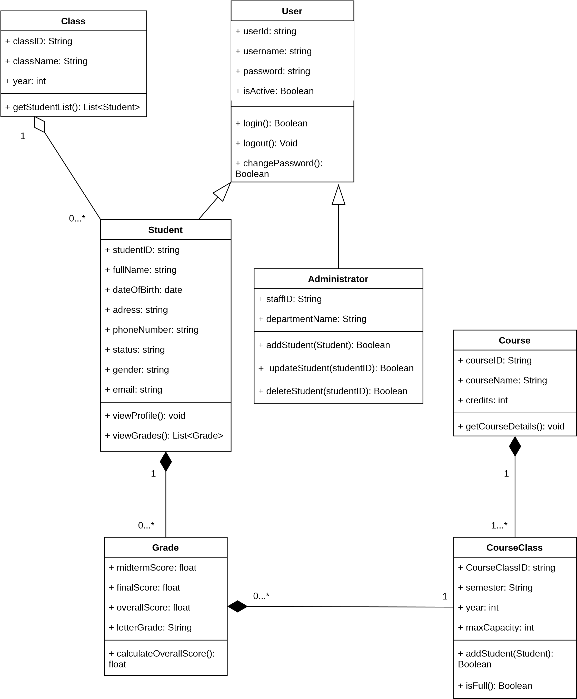

- Data model
Users
PK
UserID
inte
g
er
Username varchar(50)
Password varchar(20)
Is_active boolean
Student
PK
StudentID inte
g
er
FK
ClassID integer
Fullname varchar(50)
Date_of_birth date
Address varchar(300)
Phone_number integer
Status varchar(50)
Gender varchar(10)
Email varchar(100)
FK
UserID integer
Username varchar(50)
Password varchar(20)
Is_active boolean
Class
PK
er
g
ClassID inte
Classname varchar(50)
Year date
Course
PK
g
er
CourseID inte
Coursename varchar(50)
Credit integer
Administrator
PK
StaffID inte
g
er
Department_name varchar(50)
FK
UserID integer
Username varchar(50)
Password varchar(20)
Is_active boolean
Grade
FK
er
g
StudentID inte
FK
CourseID integer
Midterm_score decimal
Final_score decimal
Overall_score decimal
Letter_score char(3)
Course Class
PK
g
er
CourseClassID inte
FK
CourseID integer
Semester varchar(50)
Year date
Maxcapacity integer

- Interface Design Description

Login screen
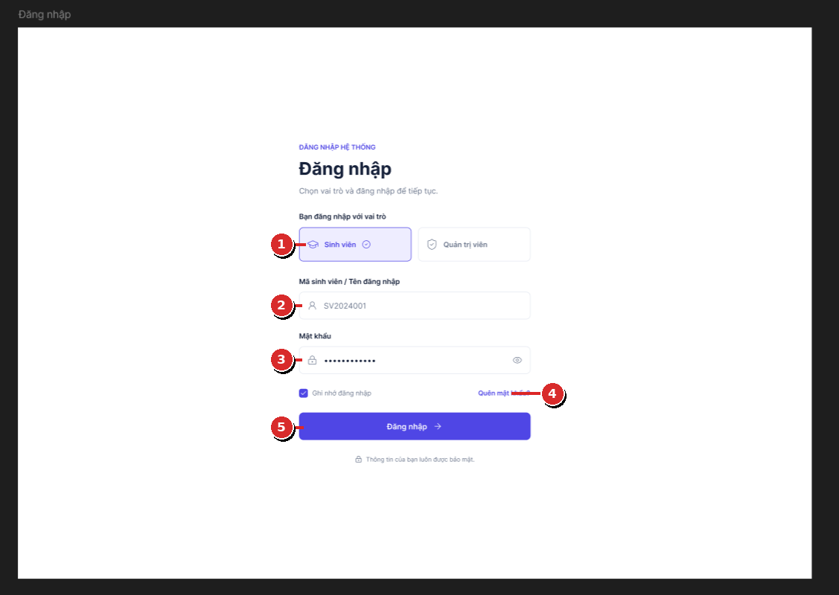
Figure 5.1. Login screen
Description of the objects on the screen:
No. | Name | Function
1 | Role_Selection | Allows the user to select the login role as Student or Administrator. The role is used to determine the corresponding interface and access rights after login.
2 | Username_Input | Allows the user to enter the student ID or username of the account.
3 | Password_Input | Allows the user to enter the password to authenticate the account. The password content is masked while being entered.
4 | Forgot_Password_Link | Allows the user to go to the password recovery process when they do not remember their login password.
5 | Login_Button | Sends the login information to the system for authentication. If the information is valid, the system grants access according to the selected role, if invalid, an appropriate error message is displayed.

Student personal information screen
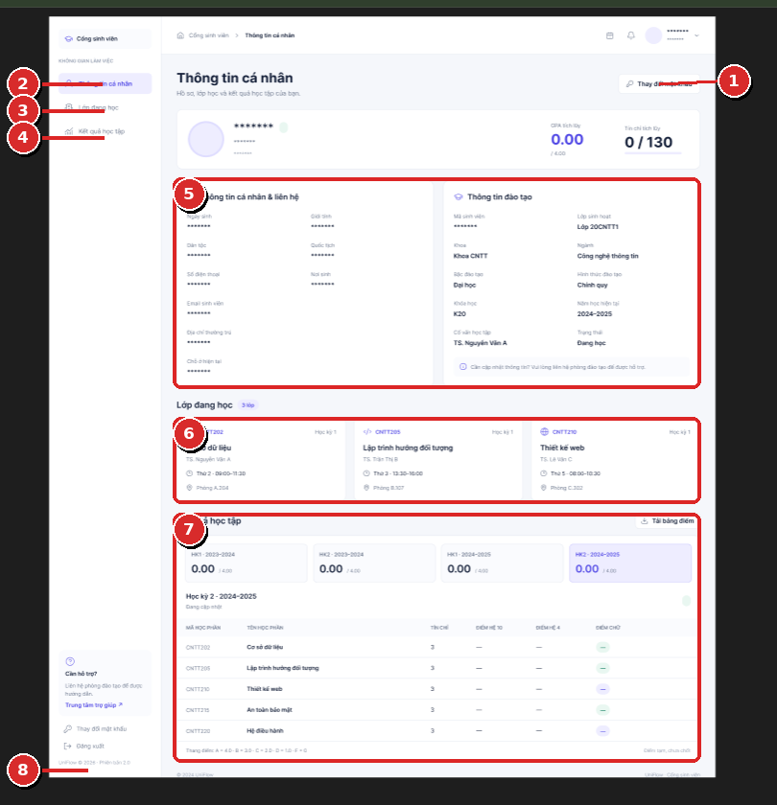
Figure 5.2. Student personal information screen
Description of the objects on the screen:
No. | Name | Function
1 | Change_Password_Button | Opens the change password screen for the student to update the account password.
2 | Personal_Info_Menu | Goes to the student's personal information screen.
3 | Current_Class_Menu | Goes to the section displaying the classes the student is currently enrolled in.
4 | Academic_Results_Menu | Goes to the section displaying the student's academic results.
5 | Personal_And_Training_Info_Panel | Displays the student's personal and training information, such as student ID, full name, contact information, class, and academic status.
6 | Enrolled_Classes_Panel | Displays the list of classes or courses the student is currently enrolled in, along with identifying information and the class schedule if this data is managed by the system.
7 | Academic_Results_Panel | Displays academic results by semester and subject, the overview area may display the GPA and the number of accumulated credits according to the system data.
8 | Logout_Button | Ends the current working session and returns the user to the login screen.

Overview screen (Dashboard)
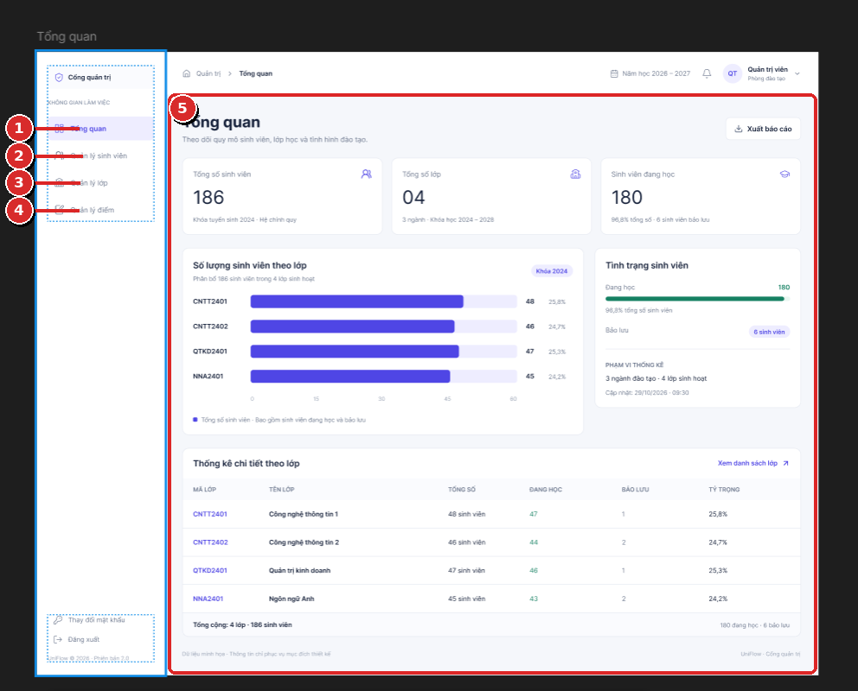
Figure 5.3. Overview screen for the administrator
Description of the objects on the screen:
No. | Name | Function
1 | Dashboard_Menu | Opens the Overview screen for the administrator to monitor the general status of the system.
2 | Student_Management_Menu | Goes to the student management screen.
3 | Class_Management_Menu | Goes to the class management screen.
4 | Grade_Management_Menu | Goes to the grade management screen.
5 | Dashboard_Statistics_Panel | Displays overview figures including the total number of students, total number of classes, number of students currently enrolled, and statistics on the number of students per class in the form of statistic cards, charts, or tables.

Student management screen

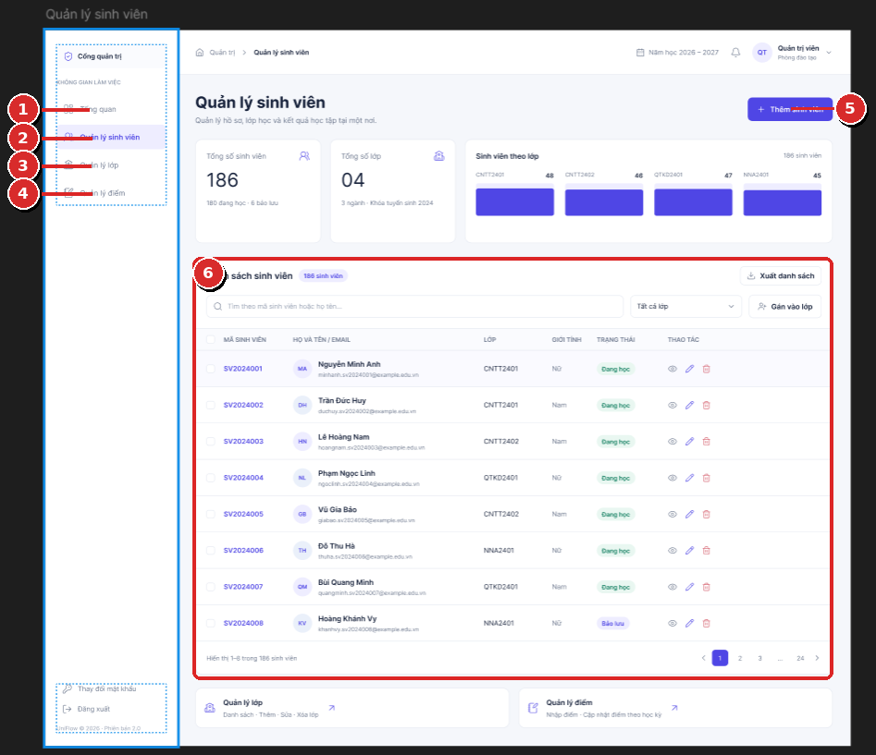
Figure 5.4. Student management screen
Description of the objects on the screen:
No. | Name | Function
1 | Dashboard_Menu | Goes to the Overview screen.
2 | Student_Management_Menu | Opens the student management screen, this item is highlighted when the administrator is on the current page.
3 | Class_Management_Menu | Goes to the class management screen.
4 | Grade_Management_Menu | Goes to the grade management screen.
5 | Add_Student_Button | Opens the add student form for the administrator to enter information and create a new student record.
6 | Student_List_Panel | Displays the list of students with information such as student ID, full name, email, class, gender, and status. This area supports searching, filtering by class, pagination, and access to view, edit, or delete student actions.

Class management screen
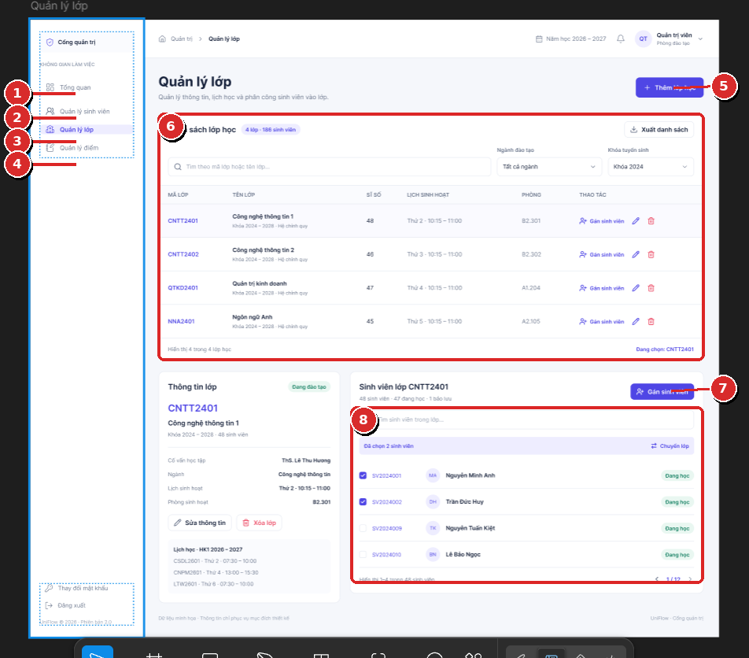
Figure 5.5. Class management screen
Description of the objects on the screen:
No. | Name | Function
1 | Dashboard_Menu | Goes to the Overview screen.
2 | Student_Management_Menu | Goes to the student management screen.
3 | Class_Management_Menu | Opens the class management screen, this item is highlighted when the administrator is on the current page.
4 | Grade_Management_Menu | Goes to the grade management screen.
5 | Add_Class_Button | Opens the add class form for the administrator to enter information and create a new class.
6 | Class_List_Panel | Displays the list of classes, including class code, class name, number of students, schedule, classroom, and class management actions.
7 | Assign_Student_Button | Allows the administrator to open the function for assigning students to the currently selected class.
8 | Student_Selection_Panel | Displays the list of students related to the currently selected class, allowing searching and selecting students to perform assignment or class adjustment actions.

Grade management screen
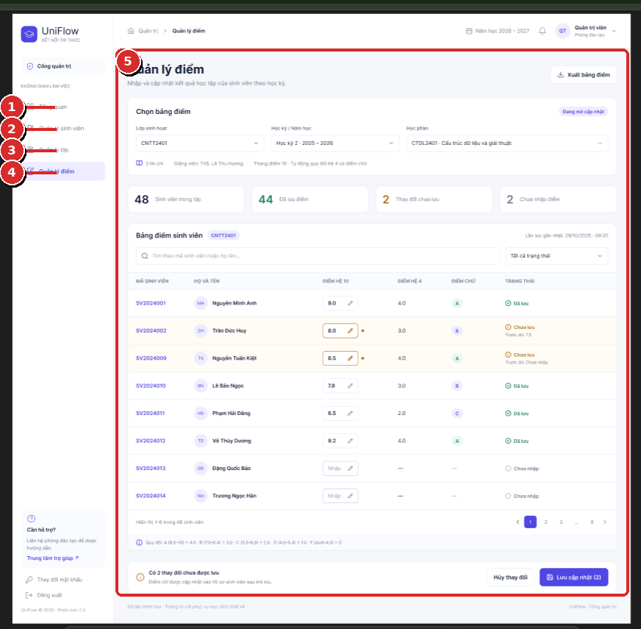
Figure 5.6. Grade management screen
Description of the objects on the screen:
No. | Name | Function
1 | Dashboard_Menu | Goes to the Overview screen.
2 | Student_Management_Menu | Goes to the student management screen.
3 | Class_Management_Menu | Goes to the class management screen.
4 | Grade_Management_Menu | Opens the grade management screen, this item is highlighted when the administrator is on the current page.
5 | Grade_Management_Panel | Allows the administrator to select the class, semester/academic year, and course, view the list of students along with existing grades, enter or update grades, track the save status, and confirm the saving of changes.

Change password screen
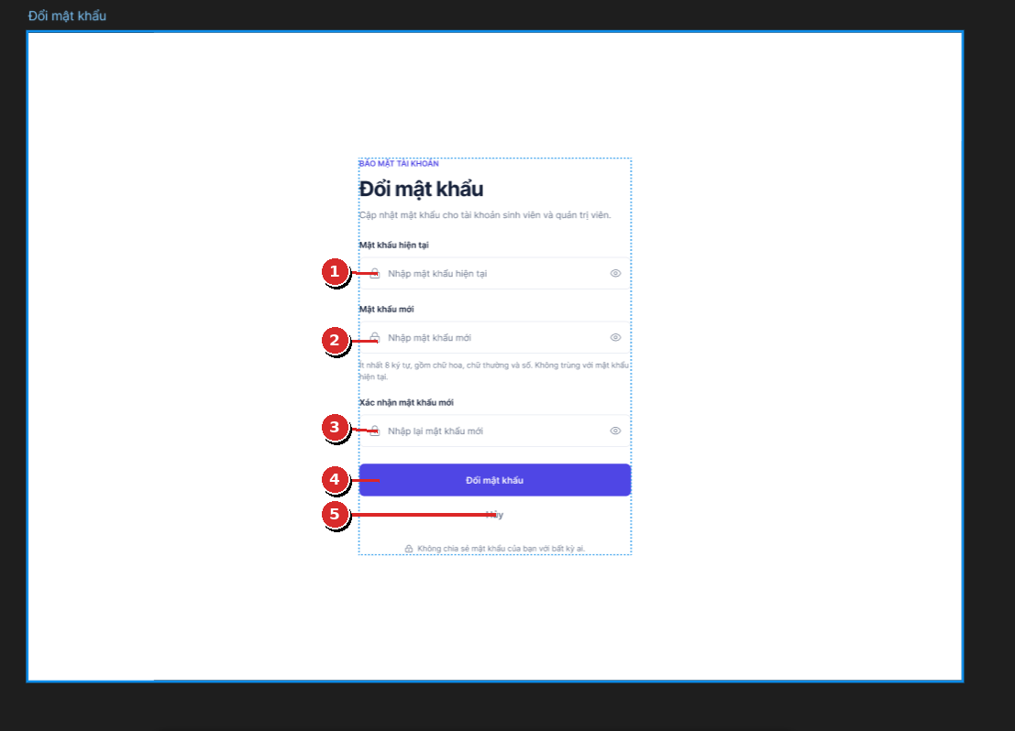
Figure 5.7. Change password screen
Description of the objects on the screen:
No. | Name | Function
1 | Current_Password_Input | Allows the user to enter the current password to verify identity before changing the password.
2 | New_Password_Input | Allows the user to enter a new password. The password must meet the system's requirements for length and character composition.
3 | Confirm_Password_Input | Allows the user to re-enter the new password to confirm that the two entries match.
4 | Change_Password_Button | Submits the change password request. The system checks the current password, validates the new password, and saves the new password if all conditions are met.
5 | Cancel_Button | Cancels the change password action and returns to the previous screen without saving changes.

